21th December 2023

Dear colleagues,

We can look back on a successful year for our Society. The congress in Lisbon, which we organized as a joint congress with the pathologists, was the highlight of the year!

Special thanks go to Nes, who did a fantastic job with her team.

In addition to numerous highlights of the congress, we were able to induct a prestigious new member, Urs Giger, into our "Hall of Fame".

But we were also very active outside of the congress, for example by organizing so-called „Expert Rounds“, in which specialists from our field gave presentations on their respective areas of work. We will continue this series next year and look forward to your participation. The 2024 congress, which will take place in Budapest, is already at an advanced planning stage and we are already looking forward to a few informative and enjoyable days in Budapest.

As the year draws to a close, we wish you a Merry Christmas and a Happy New Year 2024, which we hope will be a successful one for you all.

On behalf of the board

Stephan

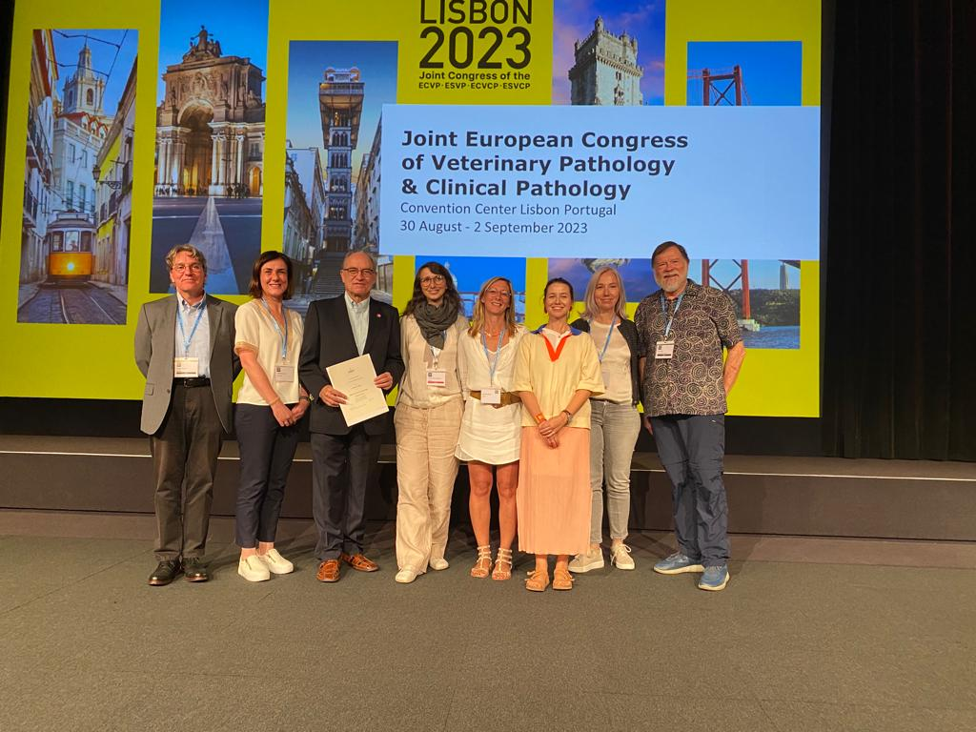

The Board (Stephan, Yolandi, Stefanie, Laetitia, Nes and Barbara together with Urs Giger and John Harvey, both members of the “Hall of Fame”)

