SUBCUTANEOUS MASS OVER THE CRANIODORSAL ASPECT OF THE LEFT SCAPULA IN A CAT

Charalampos Attipa, Rachel Hampel, Simon L. Priestnall, Kate English
Pathobiology and Population Sciences, Royal Veterinary College, Hatfield, UK

Signalment:
A 9-year-old, neutered male, domestic short hair cat

History:
This patient was presented to the Queen Mother Hospital for Animals, Oncology Service, Royal Veterinary College, UK, for investigation of a rapidly growing subcutaneous mass near left scapula. According to the referring vet the mass had been present for a month and the cat had been vaccinated against FeLV and rabies.

Physical examination:
On presentation the cat was bright alert and responsive. His vital parameters were within normal limits. A mass was present subcutaneously over the craniodorsal aspect of the left scapula. It was freely mobile and did not appear attached to underlying tissues. The mass was firm and lobulated in texture but non-painful. It measured 3.6 cm x 1.2 cm. Peripheral lymph nodes were within normal limits. Thoracic auscultation and abdominal palpation were normal. Ralph had a body weight of 3.9 kg and a body condition score of 4/9.

Diagnostic procedures:
Haematology: Lymphocytes mildly decreased at 0.82x10^9/l (RI 1.5 - 7x 10^9/l).
Serum biochemistry: Mild increase in CK at 576 U/l (RI 52 - 506 U/l).
Rest within normal limits.

CT scan: Thorax: Subcutaneous mass between skin and left supraspinatus muscle. Mass has low attenuation (22HU) in pre-contrast images and accumulates contrast mainly around its periphery. Adjacent muscle and bone do not appear to be invaded. No enlarged nodes identified.

Fine needle aspirates from the subcutaneous lesions were performed and submitted for evaluation (Images 1 – 4).

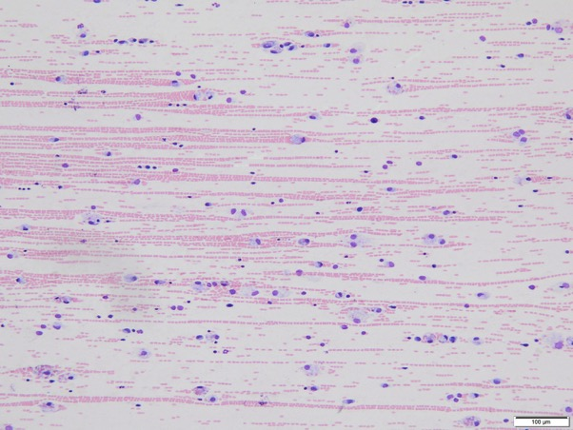
Image 1. FNA smear from a subcutaneous mass over the craniodorsal aspect of the left scapula in a cat (10x objective, modified Wright’s stain).

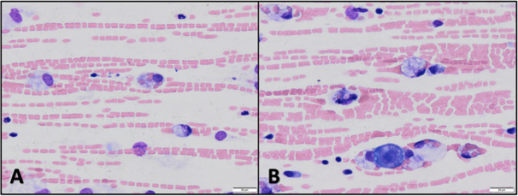

Image 2. FNA smear from a subcutaneous mass over the craniodorsal aspect of the left scapula in a cat (50x oil objective, modified Wright’s stain).

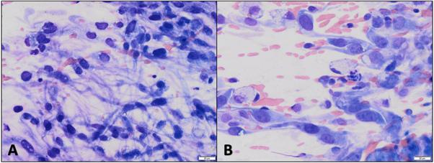
Image 3. FNA smear from a subcutaneous mass over the craniodorsal aspect of the left scapula in a cat (50x oil objective, modified Wright’s stain).

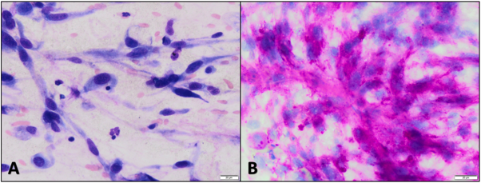

Image 4. FNA smear from a subcutaneous mass over the craniodorsal aspect of the left scapula in a cat.
- 50x oil objective, modified Wright’s stain
- 50x oil objective, PAS stain

Question:
Based on clinical presentation and the cytology findings, what would be your main differential diagnoses?

